Software Application Idea:
Anthony Bianco

Create a subscription-based search algorithm for exploring careers using correlative data.

Assumptions: Any career (law, medicine, civics, arts, engineering) have extra – often hidden – behaviors associated with the profession, and for one to be in that profession, it helps to know about and partake in those activities.

For example, there is probably a strong positive correlation between practicing law and playing golf. Furthermore, lawyers – as a group – are more likely to consume different reading material and entertainment than other professions.

As a practicing lawyer or as an aspiring lawyer – here comes another big assumption—, it would be helpful to know what others of the profession consume.

So, creating a database of the consumptive behaviors of a group of professionals could help.

One could search up “Lawyer” and receive organized data on the consumption patterns of that profession: This is where lawyers shop, what they read, what restaurants they dine at, what sports they play, what high schools they went to, what majors and minors they have, what extracurriculars they did, etc..

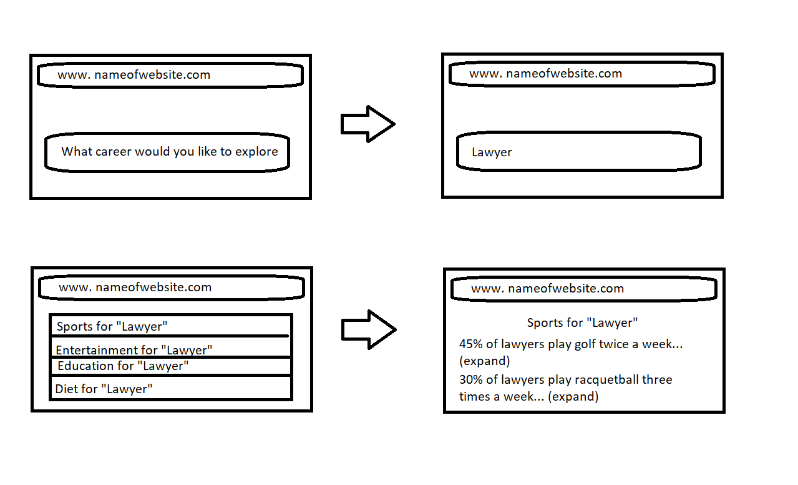
Not only could this database be used for exploring careers but also could also be used for other things. For example, typing in ‘guitar players’ would yield correlative data about ‘guitar players’. This application would have both a personal subscription user and a business option.

